**Mobile App Design Document (UFCF7H-15-3)**

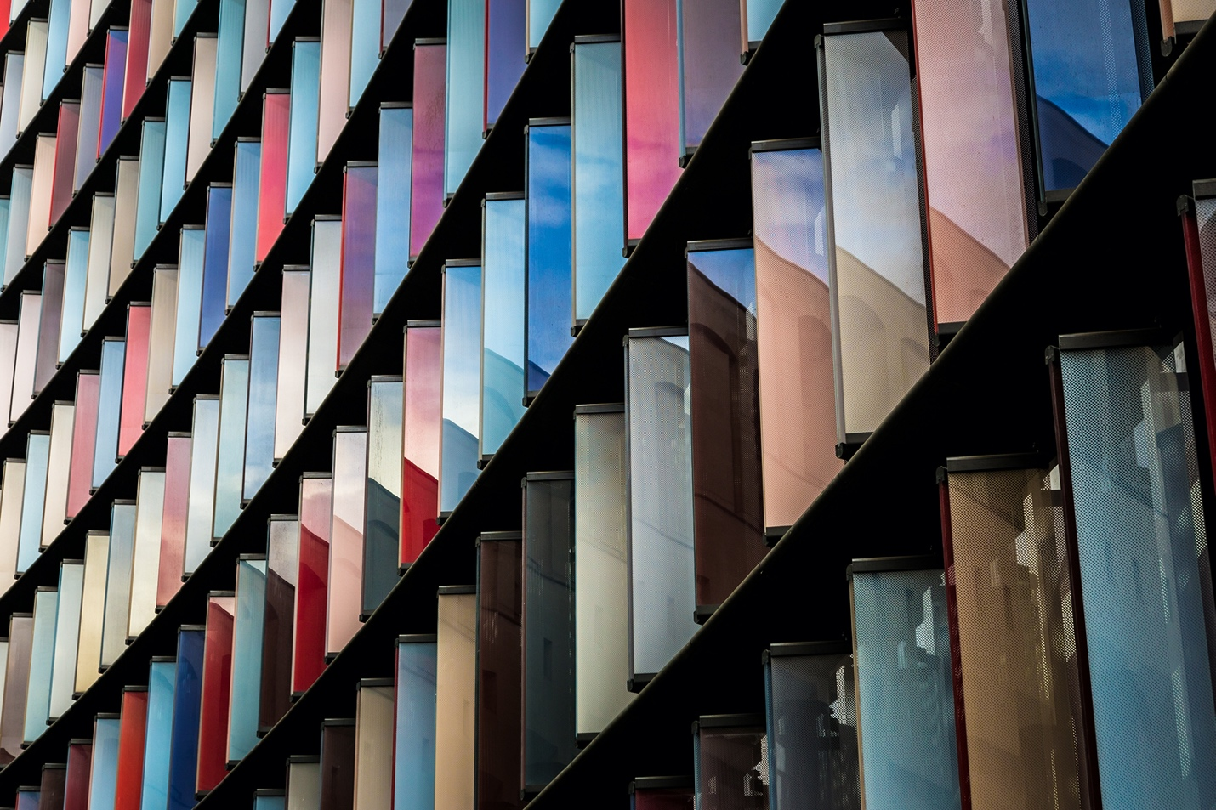

*Nice image here. Create a cover page.*

**Film Swipe**

**Student Name:**

**Student Number:**

**\*\*\*REMOVE THIS TEXT BEFORE YOUR SUBMISSION\*\*\***

Documentation is expected to vary between students based on individual approaches, knowledge & skills around mobile app design & development. This template is a starting point, but you may wish to include additional content on top of what is included here **or** remove subheadings if they do not apply to your app design. Use of images and diagrams is recommended throughout.

Also… this template is rather boring (and in Comic Sans). Feel free to freshen it up to help communicate your design, whilst retaining the basic structure. Presentation will be considered, but not over the quality of the content.

**Table of Contents**

Requirements 2

***The following are recommendations that you may wish to include. Remove as necessary*** 3

Context / High Concept: ? 3

Target Users: ? 3

User Stories: ? 3

Initial Research: ? 3

Functional / Non-functional Requirements: ? 3

UI Requirements: ? 3

Wireframes 3

***The following are recommendations that you may wish to include. Remove as necessary*** 4

Technical Diagrams: 4

User Flow / Navigation: 4

Scale / Orientation: 4

Composites 4

***The following are recommendations that you may wish to include. Remove as necessary*** 4

Mock-ups: 4

App Icon: 5

Colour Schemes: 5

UI Asset Scale: 5

# **Requirements**

## *\*\*\*The following are recommendations that you may wish to include. Remove as necessary\*\*\**

## Context / High Concept: ?

Short and sweet. People should read this and understand everything about your app and what it does with no additional questions.

Film Swipe is a personalized film discovery mobile application that combines ease of use with a “swipe right” and “swipe left” interface. Users are able to explore movies by swiping right to add films to a "liked" list and left to discard them. There is quick access to detailed information on each film, including synopsis and genre, allowing users can make well informed choices (TBD). A search feature allows users to find and manage specific films, and a profile section which houses their liked films and profile information. The aim of the app is to simplify film exploration into an enjoyable intuitive experience for all types of users.

## Target Users: ?

Who is your app for? Age group, demographic? This will help establish the goals of your design.

The Film Swipe App is designed for anyone aged 13 and over who enjoys discovering new films. This broad audience includes casual viewers and avid movie fans looking for an interactive way to explore new films. (TBC?)

## User Stories: ?

Sometimes depending on the functionality of your app, you may wish to include a user story that explains how people would use your app in context.

## Initial Research: ?

It is likely someone has made a similar app before. What information/ideas can you extract from existing apps? Do not just limit yourself to apps similar to your design, as inspiration can come from anywhere.

## Functional / Non-functional Requirements: ?

Provide details about what is needed to achieve your app goals, such as sourcing APIs, external libraries, asset collections and more. Think technically about what you need to create your final app and how you will use them. There is also opportunity to discuss development approach and system architecture, use of models etc.  and inclusion of local storage/database with types and descriptions if this is being used.

* **APIs and External Libraries**:
  + **API**: We will use the TMDb API for film data, including film titles, synopses, and images.
  + **External Libraries:** TBC (API calls, database, swipe etc.) TBC
* **Asset Collection:**
  + We are using basic Material Icons for UI elements, aligning with a simple and modern design.
* **Technical Approach:**
  + Agile development. TBC
  + MVVM (Model-View-ViewModel) pattern will be used for structuring the app.   
    NOTE FOR US: This <https://medium.com/@jecky999/mvvm-architecture-in-android-using-kotlin-a-practical-guide-73f8de1d9c58> is a good tutorial for repository pattern when we start DB work.
* **Use of Models:**
  + Data models such as Film will be created to structure and handle the response data retrieved from the TMDb API. TBC
* **Local Storage/Database:**
  + For local data storage, we plan to store liked films for offline viewing. Simple preferences like dark mode/notifications will be stored here too. TBC

TBD: Add/include requirements for all the functionalities int eh “functionalities to include.docx”

|  |  |  |  |
| --- | --- | --- | --- |
| ID | Priority | Description | Rationale |
| FR-01 | MUST | Users must be able to register and log in. | Basic functionality required for user personalisation for app features. |
| FR-02 | MUST | Users must be able to swipe right to like a film and left to discard a film on the home screen. | This is a core feature of the app and enables users to interact with films and create their list. |
| FR-03 | MUST | The app must save liked films to the user's profile. | Essential for creating a personal list of wishlist films. |
| FR-04 | MUST | Users must be able to search for films on the Search page. | Allows users to find specific films and manually add them to wishlist . |
| FR-05 | MUST | Users must be able to view detailed information (e.g., synopsis) about a film on the Search film detail page. | Provides the necessary context and detail for whether a user chooses to add a film to their wishlist. |
| FR-06 | MUST | The app must have a navigation bar with Home, Search, and Profile options available from all screens. | Essential to improving User Experience (UX) across the app. |
| FR-08 | SHOULD | Users should be able to edit their personal information and profile picture on the Profile screen. | Improves user control over their account information which improves personalization. |
| FR-09 | COULD | Users could receive recommendations based on their liked films. | Increases user engagement by suggesting relevant content but is not critical. |

|  |  |  |  |  |
| --- | --- | --- | --- | --- |
| ID | Priority | Type | Description | Rationale |
| NFR-01 | MUST | Compatibility | App must be compatible with Android SDK 30 or above. | (TBD???) |
| NFR-02 | MUST | Security | The app must securely store user data and implement basic encryption for login information. | Protects user information and builds trust in the app’s security and ensures GDPR compliance. |
| NFR-03 | MUST | Performance | The app must load film data within 5 seconds on both home & search pages. | Fast responsive times improve user experience vastly.  (could split this into 2 separate ones) |
| NFR-04 | MUST | Usability | The app must have an intuitive & easy-to-use modern UI adherent to ADA standards. | Improves the app’s usability making it easier to use and will match competitor applications. |
| NFR-06 | SHOULD | Availability | The app should provide offline access to the user’s liked films. (NEW IDEA) | Enables users to download their liked films to ensure accessibility outside of an internet connection. |
| NFR-07 | SHOULD | Compatibility | The app UI should adjust appropriately to different screen sizes. | Ensures consistent user experience on different size devices. |
| NFR-08 | WON'T | Feature Scope | The app won’t include social media integration for sharing liked films. | Outside of the initial feature scope, focusing the app on core functionality. |

## UI Requirements: ?

Through your research and learning you will identify key UI features that you feel will make your app standout. Create a list (with possible links to sources / documentation) of UI elements you will need to use to create your final app.

# **Wireframes**

## *\*\*\*The following are recommendations that you may wish to include. Remove as necessary\*\*\**

## Technical Diagrams:

We are looking for mid to high-fidelity wireframes. Clear technical diagrams that show the layout and flow of your application. This should be informed by your **Requirements**, listing UI features using standard wireframe design principles, always referring to the Human Interface Guidelines. Ideally created used created using a digital wireframing tool, such as [**these**](https://careerfoundry.com/en/blog/ux-design/wireframing-tools-ux-designers/) suggestions.

## User Flow / Navigation:

Can be included in the technical diagrams. How the app views will behave, how they are accessed and how users are expected to navigate the application should be presented communicated to the developers / client.

## App lifecycle:

There are other opportunities to include details about your applications life cycle. What happens when the app enters various stages of activity? Consider this from the programmer's perspective. What stays active? Do you save any data? How will you handle OS events?

## Scale / Orientation:

Can be included in the technical diagrams. How the app will look on alternative devices and/or orientations needs to be considered and communicated to the developers / client.

# **Composites**

## *\*\*\*The following are recommendations that you may wish to include. Remove as necessary\*\*\**

## Mock-ups:

These should be how you envision the final app looking. You know your app better than anyone, so help us understand your design fully through beautiful, finished app design composites. You can show your app in context, in different modes and in different situations. Each view should be mocked up so the client can see how what they are paying for will look like in the end. A client may also want to know what their app will look like on other devices (tablets, desktop apps etc.).

## App Icon:

Every app needs an app icon. Provide images to show how yours will look, considering scale between devices and device manufacturer requirements.

## Colour Schemes:

You will likely select a colour pallet for your app that developers will need to work from. Can you provide them as a useable reference for developers?

## UI Asset Scale:

Some features of your app scale automatically between screen sizes, however sometimes you need to produce additional assets for larger screens / resolutions. If this is the case for your app, include these here.

*\*\*\*These lists are not exhaustive. You may wish to add additional content to help your submission. Speak with a member of the module team if you are unsure.*

*The Final Report must be formatted with a professional look-and-feel. Check carefully for correct spelling and grammar before submitting the report\*\*\**